Bank Database Structure

This DATABASE of following tables :

* account_details
* customer_info
* transaction_details

------------------------------------------------------------------------------------------------------------------------------------------------------------------------------------------------

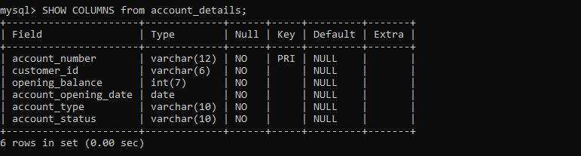

**Structure of account_details table**

This table consists of the following columns :

* account_number : This column contains the account number related to a particular account.
* customer_id : This column contains the customer_id related to a particular account.
* opening_balance : This column contains the balance of a particular account.
* account_opening_date : This column contains the the account on which the account was openend.
* account_type : This column tells whether the account type is ‘SAVINGS’ or ‘CURRENT’.
* account_status : This column tells us that whether the account is still is use or not.

------------------------------------------------------------------------------------------------------------------------------------------------------------------------------------------------

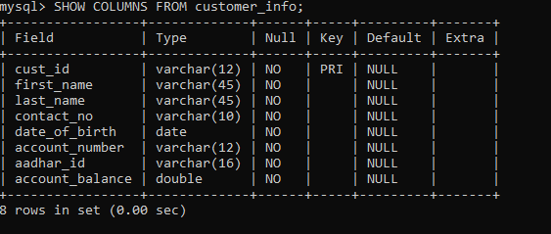**Structure of customer_info table**

This table consists of the following details :

* cust_id : This column consist of the customer ID related to a particular bank account.
* first_name : This column consist of the first name of the account holder.
* last_name : This column consist of the last name of the account holder.
* aadhar_id : This column consist of the AADHAR NO of the customer.
* contact_no : This column consist of the contact no of the account holder.
* date_of_birth : This column consist of the DOB of the account holder.
* account_no : This column consist of the account number.
* Account_balance : This columns represents the account balance.

----------------------------------------------------------------------------------------------------------------------------------------------------------------------------------------

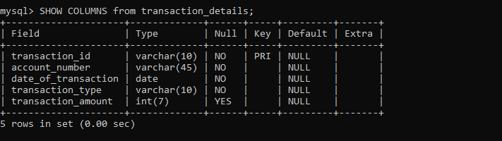

**Structure of transaction_details table**

This table consists of the following details :

* transaction_id : ID of a particular transaction.
* account_number : Account Number in which the transaction is performed.
* date_of_transaction : Date on which the transaction is performed.
* transaction type : Type of transaction performed.
* transaction_amount : Amount of the transaction.